Using iSIKHNAS data to support budget advocacy in Indonesia

**Manual**



Contents

1 Overview of budget advocacy 3

2 Using iSIKHNAS data as performance indicators 4

2.1 What are performance indicators? 4

2.1.1 What is a good performance indicator? 5

2.2 Estimating and comparing performance indicators 5

2.3 Using performance indicators to support budget requests 7

2.3.1 Monitoring performance over time 7

2.3.2 Monitoring performance against specific targets 10

2.4 Examples of performance indicator 11

2.4.1 Laboratory submission rates – surveillance 11

2.4.2 Provision of farmer clinical services 11

2.4.3 Laboratory performance indicators 12

2.4.4 Breeding Performance Indicators examples 12

3 Using iSIKHNAS data for animal health economics analyses 14

3.1 The economic process of animal diseases 14

3.2 Estimating the cost of disease 15

3.2.1 The economic effects of disease 15

3.2.2 Estimating the costs of disease 18

3.2.3 Identify the affected production systems and obtain production and economic information for these systems. 18

3.2.4 Calculate the economic impact of disease for each affected production system at the farm level 21

3.2.5 Estimate the number of affected farms in each production system within the area of interest 27

3.2.6 Calculate the total annual economic impact based on the production systems and number of farms affected in each area of interest 28

3.2.7 Assumptions 29

3.3 Estimating the costs and benefits of animal health activities 30

3.3.1 The costs of animal health activities 31

3.3.2 The benefits of animal health activities 34

3.3.3 Assumptions 35

3.3.4 Sensitivity analysis 35

4 Basic animal health economic analysis tools 37

4.1 Partial budgets 37

4.2 Cost-benefit analysis 39

4.2.1 Benefit-cost inputs 40

4.3 Gross margins analysis 43

5 Economics and budget advocacy 45

6 Conclusion 46

# Overview of budget advocacy

Ibu Tata to provide

# Using iSIKHNAS data as performance indicators

## What are performance indicators?

Performance indicators are measures that can be used to measure success in particular activities, for example:

* as progress towards a specific goals
* as achievement of an operational goal

An example of progress towards a specific goal could be reducing the incidence of Rabies in dogs by 10% in the first year of a program, where eradication is the specific goal

An example of an operational goal for a particular Kabupaten could be to respond to 95% of Priority disease reports within 24 hours. This goal is continuous and can be assessed for any period – weekly, monthly, yearly, etc.

Performance indicators must be understandable and measureable and must be relevant to the desired goal.

Surveillance of animal diseases and improving animal health are particular activities relevant to iSIKHNAS. Performance indicators can be used to measure progress or achievement of these activities.

For example some possible performance indicators for responding to an iSIKHNAS Priority disease report are:

* the number of response reports generated compared to the number of iSIKHNAS notifications
* the average time taken from the iSIKHNAS notification to the response report being received by iSIKHNAS
* Percentage of reports responded within a set period of time (24 or 48 hours)
* the number response reports generated by para-veterinarian compared to the number generated by veterinarians
* the time taken from iSIKHNAS notification to the response report generated by a telephone consult compared to the time taken for a farm visit

### What is a good performance indicator?

Good performance indicators should be:

* Specific – must clear & understandable
* Measurable – data available or can be obtained to calculate
* Achievable – goal must be something that can realistically be achieved
* Relevant – performance indicator (and goal) must be relevant to the overall outcomes for the activity
* Timely – must be measured in a timely manner depending on the goal (weekly, monthly or annual)

## Estimating and comparing performance indicators

Performance indicators are mainly useful for measurement of performance within a single district or province over time or against targets. This limitation is necessary so that measurements are useful and to prevent unfair comparisons between areas with different resources and challenges.

For example, if one district has few animals and many staff then it would be expected that their performance indicators would be much higher than an area with many animals and few staff. This doesn’t mean that the district with fewer staff and more animals are not doing their job just as well as in the better resourced district. Instead, it may be an indicator that they need more staff and resources to enable them to reach the same overall standard as the better resourced district.

To avoid this sort of unfair comparison, direct comparison of performance indicators between areas should only be done where the work environment and available resources are similar. Where this is not the case, it is important that resources and work environment should be considered in any comparison of indicators. Some of the things that should be considered include:

* the number of famers
* the number of animals or number of animal by species
* the number of animal health workers
* the number of animal health workers per 100 animals
* the number of animal health workers per 100 farmers
* numbers of reports being received
* geography of the area is it easy or hard to get around
* size of the area and infrastructure (roads, phone service and so on)
* resources (availability of vehicles, equipment, phones and so on)

For example, two Kabupaten are compared on the basis of % response to priority disease notifications (see spreadsheet *Performance indicator example 1.xlsx*). Kabupaten A responds to 24/24 (100%) whereas Kabupaten B responds to 48/54 (89%). Is Kabupaten B performing worse than Kabupaten A?

On the surface this might appear to be the case, based on just this one measure. However, if we look further it becomes less clear:

* Kabupaten A has 5 animal health workers, compared to 3 animal health workers in Kabupaten B.
* Kabupaten A responded to 23/24 (96%) notifications by phone, compared to 34/48 (71%) in Kabupaten B, so Kabupaten B did many more visits than Kabupaten A (14 compared to 1)

From this example we can see that it is unfair to compare the 2 independent Kabupaten on a single performance indicator taken in isolation. If we look at the other indicators, Kabupaten B has twice as many notifications to respond to as Kabupaten A and is still responding to most of them. It is also responding with more property visits than Kabupaten A, despite having fewer staff.

We can appreciate the usefulness of performance indicators to identify areas where there are underlying problems causing poor performance. It is this understanding and information that is useful to support budget advocacy and direct resources to where they are needed for improvement.

Remember, performance indicators are used to measure progress towards a specific goal or achievement of performance target levels. This process is aimed at identifying areas of poor performance so problems can be addressed and improve performance.

Performance indicators can be used to help describe “what’s going on” - not who’s doing better than who.

## Using performance indicators to support budget requests

Performance indicators are used to monitor and evaluate performance. This information can be used for a variety of reasons, mostly to identify and resolve of an underlying problem causing the poor performance. Target values are often set for specific performance indicators. Where performance is poor or below a set target there is a need to identify the cause and possible solutions for the poor performance.

For example, an area of weakness may sometimes be due to lack of human resources, not enough staff to deal with the work load. In these cases performance indicators might be used to support budget advocacy for more staff.

Most iSIKHNAS data can be used to generate a performance indicator(s). There is opportunity to develop performance indicators for a specific area, disease program, resource issues etc. The iSIKHNAS champions may be able to generate reports for you or you may need to conduct the analyses locally.

There are two main ways to use performance indicators for budget advocacy:

### Monitoring performance over time

Performance indicators can be used to monitor performance over time within a district or province to identify periods when performance declines and the reasons for such changes. The observed changes can then be used to argue for increased budget or resources or changes to operational procedures to overcome periods of poor performance.

For example, below is a graph of the percentage or priority reports which had a response report entered into iSIKHNAS by each week. This is one performance indicator that could be used for monitoring ability to meet targets for response reports.

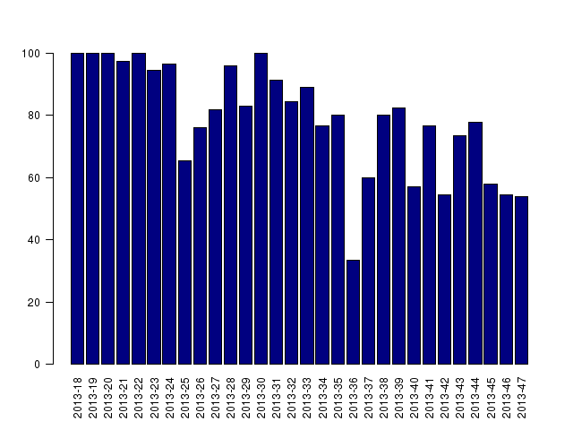

Assuming that all disease investigations were SMS’s to iSIKHNAS prior to the investigation then we may be able to use this information to support a budget request.

The decreasing response rate could be due to the successful uptake of iSIKHNAS by farmers. This could cause an increase in the reporting of disease and therefore an increase in work load for staff.

If the staff levels have not changed during this time then this information from the performance indicator could be used to support a budget request to increase staff numbers.

Additionally, if the periods of larger decreases and increases corresponded to staff holidays, staff being away and returning respectively, then this could provide more support for your budget request.

If the following year your response report performance indicator looked like the graph below, you may be able to use this to support advocacy for continuation of the current level of budget opposed to a budget cutback (performance will fall further if there are cutbacks). This may be especially useful if cutbacks are being planned.

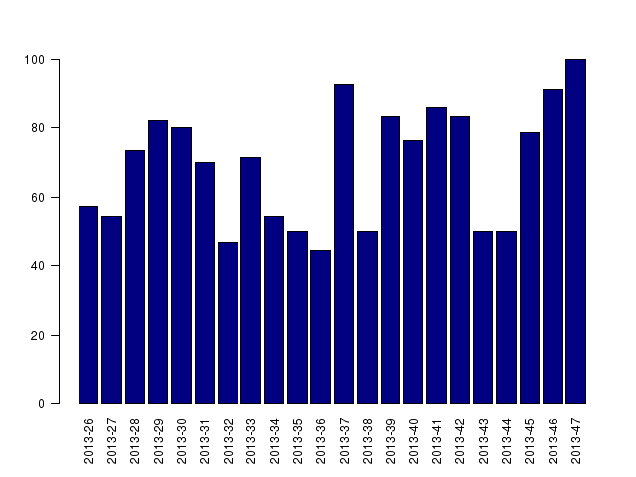

An alternative situation causing the above example could be a communication problem. This would affect response reports being sent or received. This could be due to a network issue where there is poor service or an operational finance issue where there is little money for good mobile phones and credit to be able to SMS iSIKHNAS.

If the cause was a network problem then you would expect to see a decrease in disease notification (SMS’s from farmers) as well as a decrease in response reports (SMS from animal health workers).

If the cause was due to money for mobile phones or credit then you would expect to only see a decrease in response reports (SMS from animal health workers).

The above example shows the use of animal disease surveillance data to generate relevant performance indicators. The example performance indicator was used to identify operational issues related to human resource or other factors involved in the response process.

Remember in budget advocacy you need to describe what’s going on, what it means, and what needs to be done.

Performance indicators can be used to help describe “what’s going on”.

Another example might be to monitor the quality of disease diagnosis by the following performance indicators:

- The percentage of disease investigation that resulted in a laboratory submission

- The percentage of laboratory submissions that resulted in a laboratory confirmed definitive diagnosis

These indicators can be monitored over time and if for example the percentage of investigations resulting in a laboratory submission decreases the reasons for this could be investigated and may result in a proposal for increased funding for laboratory investigations.

### Monitoring performance against specific targets

The second common use of performance indicators is to monitor performance against specific targets. If national or district policy targets exists then performance indicators should be developed to measure against these targets.

For example the following performance indicator could be used to measure performance against a target for priority disease responses:

- percentage of priority disease responses received in a time period after notification to iSIKHNAS.

The performance target could be set at (for example) 100% in 24hrs, or 80% in 24hrs and 100% in 48hrs (or some other agreed value).

If performance falls below the target values the reasons for the fall should be investigated and a proposal prepared to correct the likely cause. For example if staff holidays cause a reduction it may be reasonable to propose employing temporary staff to cover the holiday period.

## Examples of performance indicator

### Laboratory submission rates – surveillance

Currently districts do not allocate any budget for laboratory testing for non-priority cases, so farmers have to pay for any testing done. This means fewer samples are tested and many investigations remain without a diagnosis. If districts provided a budget for sampling a percentage of non-priority cases, for example 5% of non-priority cases with samples submitted for laboratory testing. This would have significant benefits for farmers and the community, including:

* Better services to farmers
* Improved district level surveillance of endemic diseases
* Self-learning capacity for paravets – they would get better at recognising diseases
* Better choice of treatment (this could be a performance indicator for the program)
* Improved accuracy of paravet diagnosis (this could also be a performance indicator for the program)
* Support planning training needs
* identification and diagnosis of new diseases in the district or of disease outbreaks occurring

Implementation could be monitored by setting a target level for funding, as a percentage of cases, and monitoring this over time.

### Provision of farmer clinical services

There are many performance indicators that could be used to monitor performance of field animal health services to farmers. However, it is important that these are consistent and that a few indicators are chosen to monitor, rather than trying to monitor everything. Some examples have already been discussed, but examples include:

* time to respond to a priority disease report
* percentage of priority responses within 24 or 48 hours
* percentage of priority cases with laboratory samples submitted
* percentage of priority cases with a diagnosis
* percentage of responses as visits compared to by telephone
* percentage of all cases with laboratory submissions
* percentage of cases with diagnosis of priority disease
* percentage of cases with zoonotic diagnosis
* percentage of cases that received treatment
* percentage of cases the district veterinarian became involved
* numbers of reports/disease investigations/responses by geographic area
* percentage of reported priority disease investigated

### Laboratory performance indicators

Performance indicators can also be used to monitor laboratory performance. For example, for priority diseases it is important to get a diagnosis confirmed quickly, so it may be appropriate to set and monitor performance indicators for laboratory performance, such as:

* time from submission to reporting results for specific diseases or tests
* The percentage of disease investigation that resulted in a laboratory submission
* The percentage of laboratory submissions that resulted in a laboratory confirmed definitive diagnosis
* number of tests performed for a particular test
* proportion of tests that are positive (or negative)

### Breeding Performance Indicators examples

Performance indicators can be used to monitor the performance of breeding cattle, particularly dairy cows. Failure to achieve these target values may indicate a possible infertility problem in the herd for further investigation.

* Mean calving to conception interval 85d
* Mean calving to first service 65d
* Mean first service to conception interval 20d
* Pregnancy rate first service 60%
* Pregnancy rate all services 60%
* Overall culling rate <18%
* % served of cow calved 95%
* % conceived of cows served 85%
* % of inter-service interval 18-24 days 60%
* Submission rate 90%
* Abortion rate %
* Dystokia %

# Using iSIKHNAS data for animal health economics analyses

## The economic process of animal diseases

Economics is concerned with converting resources or inputs (animals, land, labour, feed and so on) into products (meat, eggs, milk) that are consumed for the benefit of people. This is done by comparing the monetary value for the resources used to produce a product with the value of that product when it is sold. Diseases can affect both the cost of production (costs of treatment and prevention) and the value of the product that is produced (deaths, reduced amount of product). Benefits can also be measured at a broader level, for example as reduced price for a product through improved disease control and productivity.

Animal disease has a range of potentially adverse effects that can be presented in economic terms. Economics uses monetary units (rupiah) to estimate the cost of disease and the benefits of control or prevention measures to help make better decisions about disease control. These principles can be applied to an individual farm, to a group of farms (such as all farms in a Kabupaten or Province) or to an entire industry (all poultry farms in Indonesia).

When we consider economics in relation to government budgets then the benefits of disease control include benefits to the wider community (for example reduced prices or safer product). When we consider economics in relation to a farm, then the benefits can be thought of as the value of the product sold.

For economic analysis - a disease is a condition affecting animal health in a way which society would prefer not to exist, because of their cost to the community, through effects on human or animal health or animal productivity.

Examples of animal diseases that society may prefer not to exist:

* Infectious diseases such as: Rabies, Brucellosis, Pinkeye, Worms
* Non-infectious diseases such as: Bali-ziekte, poor nutrition
* Zoonotic diseases of public concern such as: Anthrax, Brucellosis, Rabies, highly pathogenic avian influenza
* Animal welfare issues of public concern such as: condition of animals production systems that are not publically accepted (e.g. sow farrowing crate in many countries around the world)

Animal health economics allows estimation of the economic impact of disease and of disease control activities. It helps the development of disease control programs which improve animal health management to gain the maximum benefit from the available resources. Animal health economic analyses can be complex and difficult to understand. This reflects the complexity of animal production systems and the difficulty in describing and valuing the impacts of disease.

Remember in budget advocacy you need to describe “what’s going on”, “what it means”, and “what needs to be done”.

Animal health economics help describe “what it means” and allows you to compare different options to justify “what needs to be done”.

## Estimating the cost of disease

In this section we will focus mainly on the losses associated with the effects of disease on the production process and within a 1 year period. Estimating the cost of disease for multiple years is more complex and is covered later (Section 4.2).

One of the major underlying issues for budget advocacy and animal health economics is estimating the cost of disease. If the cost of disease can be estimated then likely benefits (reduction of disease) from different animal health activities (prevention and treatment) can be compared. Estimating the cost of disease allows other economic tools to be used to help maximise the benefits from available resources. Using this approach also allows us to estimate the cost of disease both for individual affected farmers and also for the industry or country as a whole. The overall cost of disease also tells us how much better off we would be if we could control or get rid of the disease and how much we could afford to spend to do this.

### The economic effects of disease

Disease impairs the process of livestock production in a number of ways. There are ***direct*** and ***indirect*** effects of disease.

***Direct effects***

The ***direct*** effects of disease occur at the farm level on the production process. These are:

* death or destruction of animals due to disease (**mortality**)
* reduced production efficiency due to illness (**morbidity**)

The cost of mortality is easy to understand as itcauses a direct (immediate) loss by the death of the animal. The cost of morbidity is more difficult to understand. Morbidity (diseased animals) affects production by reducing the animal’s efficiency. This can be seen within production systems as:

* a reduction in products from the same amount of inputs

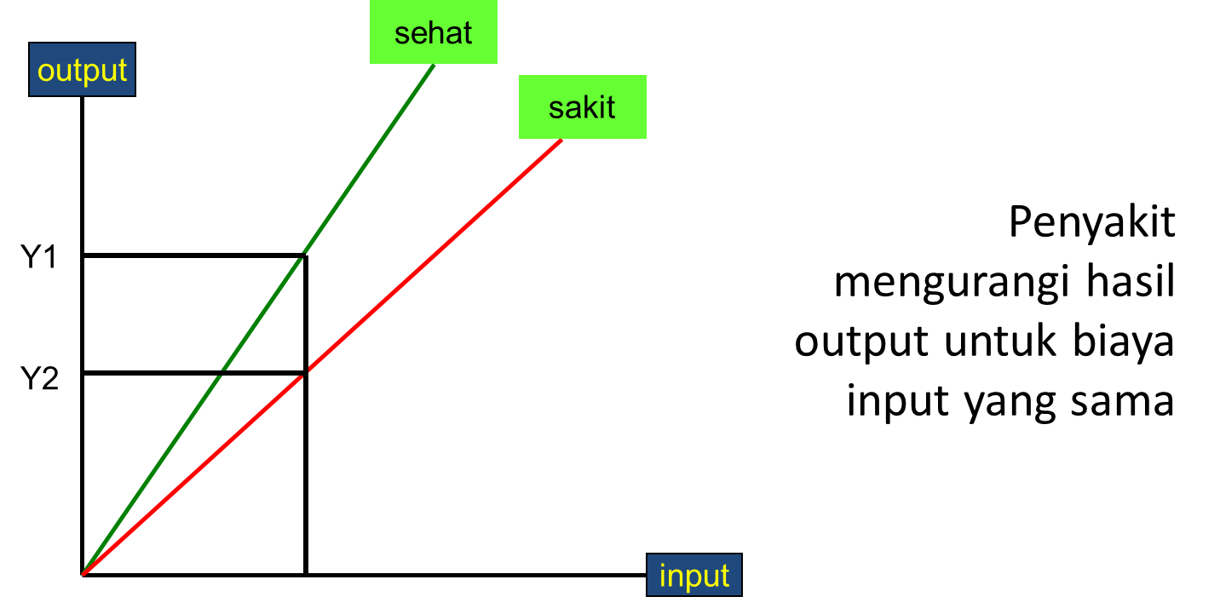

For example, sick birds lay fewer eggs even though they are fed the same amount and other costs such as labour are unchanged.

* or an increase in inputs to achieve the same amount of products

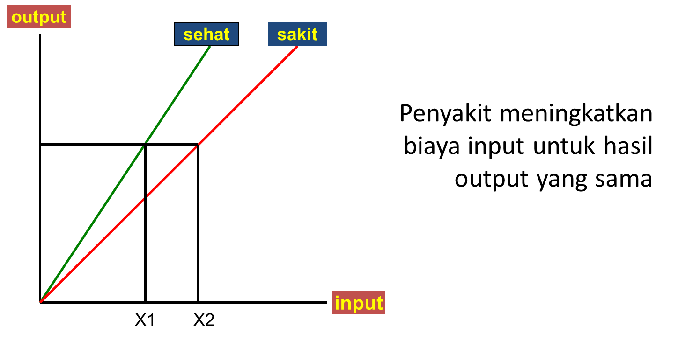

For example, sick birds continue to lay the same number of eggs but require increased feed and veterinary medications to do so.

Morbidity reduces the animal ability to produce a product and can occur though many ways, for example:

* a decrease in reproduction performance can be caused by:
  + an increases in abortions
  + a reduction in conceptions
* a decrease in daily weight gain or daily milk volume can be caused by:
  + a reduced feed efficiency
  + a reduced amount of energy being available to the animal from the food eaten due to energy being diverted to the disease process or infectious organism
  + inability to access feed due to disease such as lameness

***Indirect effects***

The ***indirect*** effects of disease refer to wider economic effects of disease and are more difficult to quantify. Indirect effects occur both on the production and consumption processes. Indirect effects of disease include:

* the costs of treatment or prevention (drugs, vaccine)
* the time period required for the farm to return to the level of production prior to the disease (**foregone income)**
* a lower suitability of livestock products for processing or distribution (such as damaged skins from screw worm fly)
* affects to humans well-being (from zoonoses)
* a reduction in the value of livestock to society (trade/tourism, public concern about food quality, animal welfare issues, etc.)

There are other economic effects of disease such as farmers unaffected by a disease will benefit as presence of the disease in other farms may cause the price of products to increase due to the shortage of supply. These wider (macroeconomic) effects are very difficult to estimate and not considered further in this course.

Estimating the exact economic impact of disease can also be very complex. However, for budget advocacy a simplified estimate of the impact of disease which allows comparison of different animal health activities is often all that is needed.

Remember in budget advocacy you need to describe “what’s going on”, “what it means”, and “what needs to be done”.

The cost of disease helps describe “what it means” and allows you a comparison to justify “what needs to be done”.

### Estimating the costs of disease

Estimating the costs of disease can be broken down into the following steps:

1. Identify the affected production systems (e.g. chicken, layer/broiler/native, or cattle breeding etc.) and obtain production and economic information for these systems.
2. Calculate the cost of disease for each affected production system at the farm level (or at the animal level if this is easier)
3. Estimate the number of affected farms (or animals) in each production system within the area of interest.
4. Calculate the total annual cost based on the production systems and number of farms affected in each area of interest

### Identify the affected production systems and obtain production and economic information for these systems.

Once the affected production systems have been identified then production system estimates need to be obtained. Many sources of information may need to be used, including iSIKHNAS, Badan Pusat Statistik, industry bodies, etc. If data is not readily available some research may be required to get estimates. Data on the average levels of production for each system is required and could include:

* Population
* Production system details, farm sizes, normal mortality rates, reproduction rates, etc.
* Animal population data including age groupings etc.
* Average products produced per cycle or year
* Average prices received for products
* Average prices for major costs for the production system

It is relatively easy to identify the production systems a disease of interest affects. Determining the production and economic characteristics for these systems is more complicated. The main problem is deciding on how detailed or accurate does the analysis need to be? The level of accuracy most likely required for budget advocacy will be somewhat lower than an academic or economists approach.

The more detailed an analyses is required the more difficult it is to obtain appropriate information. The average costs of the major inputs and products are easier to obtain than many smaller costs such as labour, buildings, electricity, vehicles, etc. In general averages are used to estimate the economic characteristics of a production system. Therefore, simple analyses using available information tend to overestimate profit margins of productions systems because many of the smaller costs are not accurate or included. There are theoretical issues with conducting simple analyses but remember the aim of these analyses is to support budget advocacy.

Assumptions are often made in these types of analyses, these assumptions need to be clearly described and explained when presenting results.

**Estimating the cost of disease - HPAI**

**STEP 1**

To estimate the cost of HPAI we first need to identify the affected production systems. This can be done by identifying the species or breeds of birds used in production, and the production purposes. For example we can classify birds used in farming as:

- Chickens. Ducks, etc.

- Broilers for meat production or Layers for egg production or Native chickens in backyards used for dual purposes of meat and egg production

For each of these systems we need to determine some production & economic characteristics. A simple analysis might only include:

- Quantity and value of inputs per bird

- Initial cost of bird

- Feed costs

- Quantity of products per bird:

- Number of eggs//bird/time period

- Number of bird for sale/time period

- Value of products

- IDR per egg

- IDR per bird

For this example we will only consider broiler farms. We could repeat the analysis for other farm types and add them together if the aim was to estimate the cost of disease for the entire poultry industry.

**Broiler production example**

For a simple analysis a broiler chicken production systems characteristics may look like the following example:



In this example we assume that:

* the average farm size for broiler farms is 8,000 birds
* the average cost of 1kg of feed is IDR 3,500 and it takes 4 kg of feed to produce a broiler to sell
* the average cost of a chick to buy is IDR 5,000
* it takes on average of 1.05 chicks to produce a broiler to sell. This accounts for the background mortality rate which is the deaths expected during normal production when the disease is not present. The background mortality rate is 5% (0.05) so the quantity of chicks required to produce 1 broiler is 1.05. If we wanted to produce 100 broilers then we would need to start with 105 chicks. Doing this enables us to include the cost of the birds that die during production in the estimates. There are other ways to include the cost of background mortality but this is a simple approach.
* It is assumed that the average sale price of a sale chicken is IDR 30,000.

There are many assumptions or information that have not been included. Calculations using this limited information will most likely be an underestimate of true costs of production, as cost such as staff wages, animal health treatments/vaccines, buildings, and power, etc. have not been included.

### Calculate the economic impact of disease for each affected production system at the farm level

Estimates of the effects of disease will need to be obtained from iSIKHNAS, current relevant research, or by conducting specific research projects. The information needed to be obtained to conduct analyses estimating the costs of disease are:

* Mortality estimates – how many or what proportion of animals die from a disease?
* Morbidity estimates and the effects on production or price
* Disease frequency or prevalence of a disease within an area of interest
* The time period required for a farm to return to the level of production prior to the disease (foregone income)
* Other possible indirect effects of disease

For our example, what are the losses from the direct effects of disease on production? These are:

* the destruction of the basic resource – **mortality**
* a reduction in production efficiency - **morbidity**
* the cost of treatments or prevention

**Estimating the cost of disease - HPAI**

**STEP 2**

Now we need to consider the assumption we are going to make about the disease. We will assume if a farm is infected with HPAI then all the chickens will die, either from the disease or from culling. Therefore the mortality rate is 100% and the morbidity rate is 0%.

Costs of treatment for disease have not been included due to the 100% mortality rate. It would be reasonable to include costs for disposal of dead birds and other cost associated with an outbreak of disease.



The direct cost to the farmer is calculated by multiplying the average broilers per farm by the total average revenue per broiler:

8,000 * IDR 30,000 = IDR 240,000,000.

Next we need to consider some the indirect effects of disease that affect the farm level. This is primarily forgone income. Foregone income is the period of time where the farmer cannot earn the amount of income previously due to the time it takes to recover to the level of production prior to the disease.

To estimate the forgone income the average profit margin per product is multiplied but the number of production cycles that are lost. For example, if a farm was infected with HPAI then all the chickens would die. We can make an assumption about the time period it would probably take before the farmer had chickens to sell again. This may vary depending on how the production systems are operated in the area.

In this example let us assume 2 production cycles are lost due to HPAI. The time period for a farmer to have chickens to sell after HPAI.

The forgone income is calculated by multiplying the average broilers per farm by the average profit margin per broiler by the number of production cycles missed after disease outbreak.

8,000 * IDR 10,750 * 2 = IDR 172,000,000.

To calculate the total losses due to disease we need to add the direct losses and indirect losses together. Generally this will be the losses from mortality, morbidity, cost of treatment or prevention, and forgone income.

Adding the direct losses and forgone income together the average total economic impact of HPAI per farm can be calculated.

IDR 240,000,000 * IDR 172,000,000 = IDR 412,000,000.



This spreadsheet used in this example is provided (see spreadsheet *Cost of disease examples-1.xlsx*). Any of the orange cells are able to be changed so you can see their effect on losses due to HPAI.

For a second production system we will estimate the cost of HPAI for a native chicken owner.

**Native chicken production example**

Repeating the process Step 1 and 2 that we undertook with the Broiler production example we can estimate the economic impact of HPAI on Native chicken production.

Again we need to consider the assumption we are going to make.

* The background mortality rate is difficult to estimate and also is complex to include for this example so it has been excluded (0 %) to keep the example easy to understand.
* If a farm is infected with HPAI then all the chickens will die, either from the disease or from culling. Therefore the mortality rate is 100% and the morbidity rate is 0%.
* We will assume there are 4 complete production cycles in a year. The forgone production cycles after HPAI is 2.
* In each production cycle the average farm has 4 hens, 1 rooster, 6 growers, 5 chicks, and producers 70 eggs.
* Hens and roosters are valued at IDR 75,000 each, growers at IDR 60,000 each, chicks at IDR 4,000 each, and sale eggs are IDR 1,200 each.
* The direct losses are calculated by multiplying the number of hens and roosters by their replacement value and adding this to the total average revenue per cycle:
* (4 * IDR 75,000) + (1 * IDR 75,000) + IDR 422,000 = 797,000
* The forgone income is calculated by multiplying the average profit margin per cycle by the number of production cycles missed after a disease outbreak
* IDR 422,000 * 2 = IDR 844,000.
* Adding the direct losses and forgone income together gives the average total economic impact of HPAI per farm
* IDR 797,000 * IDR 844,000 = IDR 1,641,000.
* These results overestimate the total cost as there are no production costs or background mortality rates included in the analysis.
* In the native chicken production system these production costs and background mortality rates will most likely be difficult to obtain because of the small and highly variable nature of the industry.



### Estimate the number of affected farms in each production system within the area of interest

For the third step we need to estimate the total number of farms within an area of interest and the prevalence of the disease.

Badan Pusat Statistik or industry organisations are possible sources of data for the number of farms within geographic areas. The iSIKHNAS system will help when estimating the prevalence of a disease. If sufficient data is not available then specific research studies may need to be undertaken to determine suitable estimates. Again the assumption you make in this step need to be clearly stated.

**Estimating the economic impact of disease - HPAI**

**STEP 3**

Commercial Poultry Profiling and PDSR data have been used previously to estimate the total number of flocks in a district.

For example in district A there are:

* 330 broiler farms with average 8,000 broilers per farm
* 1,599,240 native chickens. Applying our assumption that there is an average of 16 birds per native chicken farm there are 99,953 native chicken farms in district A.

We will assume of the prevalence of HPAI is 1% within each production system.

Therefore in 1 year there are:

* 0.01 * 3.3 = 3.3 broiler farms infected with HPAI
* 0.01 * 99,953 = 999.5 native chicken farms infected with HPAI



### Calculate the total annual economic impact based on the production systems and number of farms affected in each area of interest

The final step is to calculate the total annual economic impact of disease in the area.

**Estimating the economic impact of disease - HPAI**

**STEP 4**

The total annual losses from HPAI with a prevalence of 1% are:

- 3.3 * IDR 412,000,000 = IDR 1.360 billion from the Broiler production system

- 999.5 * IDR 1,621,000 = IDR 1.640 billion from the native chicken production system:

Therefore the Total annual HPAI loss is IDR 2.887 billion per year for the district of interest.

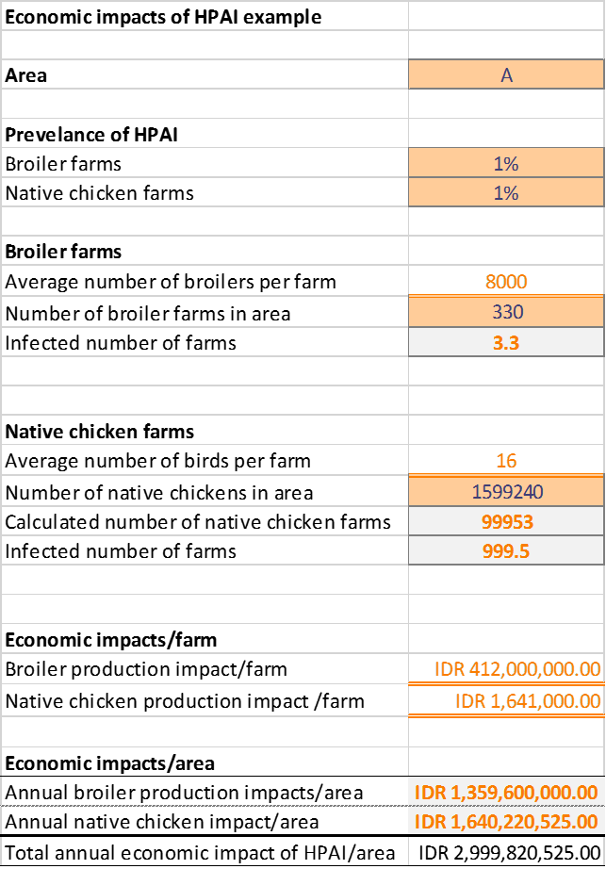

### Assumptions

You should always clearly state the source of data on which estimates are made and any assumption must always be clearly stated. Assumptions are where you don’t have data on which to base an estimate and simply choose a realistic value based on experience and personal knowledge. Assumptions allow you to conduct simple analyses in a timely manner without always having specific research data on each disease, production system, or economic factors.

For example, in the previous broiler example you might know that there are 8,000 broiler farms in the area of interest and that the average size is 330 birds, based on agricultural census or other data.

However, you might not have good data on the percentage of chicks that die or the amount of feed required for each chick, so you make assumptions about these values based on experience and knowledge of the industry.

The important thing is to be clear in describing how you determined each value in the analysis.

## Estimating the costs and benefits of animal health activities

Animal health activities aim to reduce the economic costs of the disease by reducing the prevalence and effects of the disease, or in some cases eradicating it. Eradication of a disease will avoid all future effects of the disease on production but there will be future indirect effects due to surveillance and other activities required to maintain freedom from disease.

Animal health activities can be as simple as on on-farm vaccination or treatment program to control or prevent disease (for example helminth control) through to a major Provincial or National Program to eradicate or control serious diseases affecting production or human health, such as HPAI, Rabies, brucellosis or anthrax.

For an on-farm activity, costs are usually met by the farmer and it is the farmer who also gets the benefits through healthier animals, more production, fewer deaths and better prices. For National programs, it is usually the government and farmers who share the cost and the benefits are shared by the community (reduced risk of zoonosis, better quality product and reduced prices) and the farmer (fewer deaths, better production and reduced disease control costs).

The costs of animal health activities can include:

* Treatment of affected animals
* Prevention measures including movement controls, vaccination and other measures
* Surveillance and monitoring
* Control/eradication measures such as animal destruction and disposal and disinfection and clean-up of affected farms
* Research
* Education/awareness

All these activities incur a cost and are aimed at producing benefits through reducing disease prevalence, effects of disease and their associated economic impacts. We will discuss these costs and benefits in more detail in the following sections.

### The costs of animal health activities

Cost of animal health activities are often categorised into variable and fixed costs.

* ***Variable costs*** - relate to costs that vary with the number of farms or animals seen or treated. For example diagnostic tests, vaccines, drugs, syringes, needles, travels costs, casual labour, farmer compensation, etc. To calculate these costs it is necessary to work out the cost per animal seen, and to know how many animals need to be treated/vaccinated, etc. This is sometimes referred to as the control programs running costs.
* ***Fixed costs*** – are unaffected by the number of animals seen or treated. These are made up of permanent staff costs plus capital items costs (vehicles, offices, water, electricity, computers, etc.). Fixed costs still occur even if there no animals are seen or treated.

The list below summarises some of the costs that can be expected for any major animal health activity:

* Surveillance
* Sample collection
* Laboratory testing
* Consumables
* Staff and travel costs for surveillance
* Costs of control
* Vaccine, vaccination equipment, cold chains
* Destruction and disposal costs
* Disinfection and clean-up
* Compensation
* Record keeping, computers/printers
* Operational costs
* Staff, transport/fuel, daily allowances, training
* Protective clothing, disinfectants
* Animal handling (ropes, yards?)
* Animal identification
* Tags, applicators, etc
* Certification of animal/herd status
* Program management
* Staff, equipment, materials
* Steering committee(s)
* Program monitoring and evaluation
* Passive surveillance (abortion reporting/investigation)
* Prevalence surveys
* Communications
* Public awareness, industry consultation, focus groups
* Farmer costs
* Increased labour requirement
* Increased vaccinations or other treatments
* Lost production and sales

For National or Provincial programs, most of these costs are paid by the government. However, some will be paid by individual farmers.

For simple, on-farm animal health activities, such as control or prevention of production-related diseases, costs will usually be limited to the cost of treatments or vaccinations.

**An example**

For example, we assume that you have noticed an increase in the number of abortions in cattle over the last year or 2. You estimate that perhaps as many as 5% of pregnant cows are losing their calf and that this is costing farmers (overall) up to IDR 25 billion (see spreadsheet *Cost of animal health activities - abortion investigations.xlsx* for calculations). Individual farmers are reluctant to spend money investigating an individual case and the Kabupaten doesn’t provide funding for detailed investigation. However, you think that if you could find out what is causing the abortions you may be able to recommend appropriate control measures and reduce the cost to farmers.

To investigate this you propose to do a detailed investigation of 50 abortions, including serology and post mortem and microbiology and histology on aborted foetuses. What will this cost?

The main costs and estimates of the overall cost for the project are summarised below (see spreadsheet *Cost of disease examples-2.xlsx,* worksheet *Abortions investigations*):



For this example, the estimated cost of the proposed investigation is about IDR 52 million, a lot less than the cost of the abortions to the farmers. If the investigation is successful in identifying the main cause or causes it may be possible to reduce the abortion rate back to normal levels for a relatively small cost, with a consequent large benefit to affected farmers.

### The benefits of animal health activities

The economic benefits of controlling disease through animal health activities can be measured as the reduction in loss because of the disease that is due to the activity.

BENEFIT from the animal health activity = Losses due to the disease without animal health activities MINUS losses due to the disease with animal health activities

To estimate the benefits requires knowledge of:

* Existing levels of disease and effects on productivity
* The effect of the animal health activity on the disease (reduction in prevalence)
* The effect of the reduced level of disease on production (increased sales)
* Savings in human health treatment costs, if appropriate

Data from iSIKHNAS can be used to help estimate the level of disease in the population.

Using the previous example of HPAI in native chickens, and assuming:

* currently 5% of native chicken flocks are affected each year
* there are 100,000 flocks in the area with an average of 16 birds per flock (1.6 million birds)
* cost per infected farm of an HPAI outbreak is IDR 1,641,000
* the control program will reduce the percentage of affected flocks from 5% per year to 0.5%

The current cost of HPAI in native chickens (without the control program): = Number of flocks x prevalence x cost per infected flock

= 1,000,000 x 0.05 x 1,641,000

= **IDR 8,205,000,000**

HPAI will still occur under the program but at a reduced level (0.5%). The calculation of the cost of disease under the control program is the same, except prevalence is 0.5% instead of 5%:

= 1,000,000 x 0.005 x 1,641,000

= **IDR 820,500,000**

Therefore the benefits of the program are:

= Cost without program – Costs with program

= **8,205,000,000 – 820,500,000**

**= IDR 7,384,500,000**

This doesn’t tell us how much the control program costs, just how much the benefit is to the industry and community overall.

For the abortion example, assuming you are able to determine likely causes of the abortions and implement a program to reduce abortion rates to 1% (instead of 5%) and reduce the cost of abortions from IDR 25 billion to IDR 5 billion, the benefit of the program is:

= 25,000,000,000 – 5,000,000,000

= IDR 20,000,000,000 per year

### Assumptions

Again, as was the case when estimating costs of disease, it is important to make sure you document the source of your estimates and the basis of any assumptions for your calculations.

### Sensitivity analysis

When estimating costs and benefits of animal health activities it is also important to do a *sensitivity analysis* on your results. A sensitivity analysis is used to test the importance of assumptions used in the analysis. In any analysis you normally use what you think are the “best” or most likely values for any assumptions. However, because they are assumptions you don’t know if the values you have used are correct. A sensitivity analysis is one method for testing how big an effect any errors in assumed values will have on the answer.

The process for a sensitivity analysis is as follows:

1. Identify the assumed values for which you need to do the analysis (this should include ALL values that you are uncertain about)
2. For each of these in turn enter an extreme minimum value (while all of the other inputs remain the same) and note the result. Repeat this process for an extreme maximum value.
3. Repeat for all of the other important variables identified.

At the end of the process you should have a table listing all of the variables with 3 output values, for the assumed most likely value, along with a minimum and maximum value.

The table nd graph below show the results of a sensitivity analysis for the cost of disease due to abortions in cattle (*Cost of disease examples-2.xlsx,* worksheet *Sensitivity analysis example*). This shows that the estimated abortion rate and the expected sale price for the calf are very important variables and therefore important to have reliable estimates. In comparison, mortality between birth and sale and rearing costs are both very minor and in fact make almost no difference to the result.

Table 1. Sensitivity analysis for cost of disease due to abortions (figures are in millions, values in parentheses are the minimum, most likely and maximum values used)

|  |  |  |  |
| --- | --- | --- | --- |
|  | Minimum | Most likely | Maximum |
| Estimated abortion percentage  (2%, 5%, 8%) | IDR 4,306.8 | IDR 10,767.0 | IDR 17,227.2 |
| Expected sale price (per calf)  (2m, 4m, 8m) | IDR 10,989.0 | IDR 10,767.0 | IDR 10,545.0 |
| Expected % mortality before sale  (1%, 3%, 5%) | IDR 4,947.0 | IDR 10,767.0 | IDR 22,407.0 |
| Cost of rearing per calf (veterinary treatments, feed or other costs)  (0k, 300k, 1m) | IDR 11,640.0 | IDR 10,767.0 | IDR 8,730.0 |

Figure 1. Table 1. Sensitivity analysis for cost of disease due to abortions (figures are in millions)

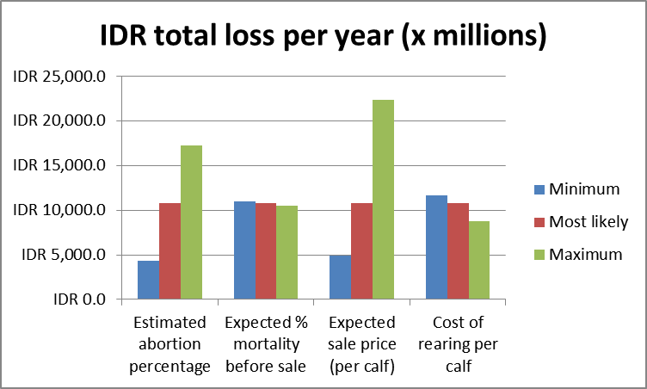

# Basic animal health economic analysis tools

Economic analyses of disease impacts may be performed at the micro-economic level (farm or household) or at the macro-economic level (industry sector or country). At the farm level the most common approaches involve partial budgets and gross margins analysis. At the sector or national level it is more common to see benefit-cost analysis (BCA) of some form.

The main tools used for economic analysis in animal health are:

* **Partial Budgets** – usually used for small animal health activities where costs and benefits directly resulting from the change can be easily measured and applied for individual farms
* **Cost-Benefit analysis** –usually used for more complex activities where the costs and benefits are less easily calculated and particularly where there are changes in costs and benefits over time.
* **Gross margin analysis –**used to analyse the impact of specific changes on performance of a farm enterprise, usually measured per unit of production (per cow, per bird, or per unit of land area).

## Partial budgets

The term *budget* simply means estimation of expected income and expenses. A *partial budget* means summarising only those changes in expenses and in income that occur when some minor change is made to management or some other input in the production system (such as using a new feed supplement or vaccinating/drenching animals). Partial budgets generally consider four components resulting from the change:

* new costs incurred (cost)
* income lost (cost)
* costs saved (benefit)
* new income (benefit)

The overall benefit of the change is estimated as the total benefits – total costs, as shown below:

Benefit = (costs saved + new income) – (new costs + income lost)

If the benefit is greater than zero then the activity is worth doing (at least on economic grounds) and if it is less than zero then it is unprofitable and you would only go ahead if there were other reasons such as a market requirement or welfare of the animals.

Partial budgets are relatively simple and may not represent all of the factors that might be relevant in a decision about investing in some change in management practices. However, they are very useful for evaluating whether or not to proceed with a simple, often minor change in management or disease control.

The example below shows a simple partial budget for whether to implement a program of anthelminthic treatment in young cattle (see spreadsheet *Partial budget example.xlsx*). The budget assumes cattle receive 4 strategic treatments at intervals prior to sale, resulting in reduced need for emergency treatment of sick animals and a 20kg increase in weight at sale. The budget does not consider animals that might die due to helminthiasis and so could underestimate the benefit. Based on the figures shown, the strategic treatment program results in an overall benefit of IDR 13 million, or 1.3 million per animal, suggesting that the program is economically very beneficial.

Partial budget for anthelminthic treatment in young cattle:

|  |  |
| --- | --- |
| **Assumptions** |  |
| Number of cattle | 10 |
| *Additional costs* |  |
| Number of treatments | 4 |
| cost per treatment | IDR 100,000 |
| additional cost per animal | **IDR 400,000** |
| additional cost overall | **IDR 4,000,000** |
|  |  |
| *Income lost* |  |
| Nil | IDR 0 |
|  |  |
| *Costs saved* |  |
| Emergency treatments (total) | IDR 1,000,000 |
|  |  |
| *Additional income* |  |
| Increased body weight (kg/animal) | 20 |
| Sale price (IDR/kg) | IDR 80,000 |
| Increased value per animal | **IDR 1,600,000** |
| additional income overall | **IDR 16,000,000** |
|  |  |
| Total costs | IDR 4,000,000 |
| Total benefits | IDR 17,000,000 |
| **Overall benefit** | **IDR 13,000,000** |
| **Benefit per animal** | **IDR 1,300,000** |

## Cost-benefit analysis

Cost-benefit analysis is simply the comparison of costs of the activity and its resulting benefits, similar to more complicated partial budget. The main difference is that in a cost-benefit analysis is usually used for larger projects and particularly projects that extend over multiple years.

Often changes intended to control or eradicate livestock disease and benefit animal production measures may take years to fully implement. In addition costs may be higher in the beginning and then reduce over time and benefits may be lower in the beginning and slowly rise over time. It is very difficult to comapre the impacts of these sorts of changes using partial budgets or gross margins analysis alone, mainly because of the time change in the value of money. One dollar earned (or spent) now is not the same as one dollar earned or spent in five years’ time, mainly because of the effects of things like inflation and interest.

Cost-benefit analysis uses additional criteria that allow for the value of money changing over time. This is done by converting the future values of benefits or costs to a value in today’s money using a discount rate. This is called the present value:

$$Present Value=PV= \frac{X_{t}}{{\left(1+r\right)}^{t}}$$

where PV=present value

Xt= amount of money in year t

R is the discount rate expressed as a proportion (5%=0.05)

T= number of years from the present date

The discount rate is also described as the opportunity cost of money. There are many different approaches to setting the discount rate. A reasonable approach is to use the *real rate of interest* which can be estimated as the current bank interest rate (cost of borrowing money) minus the inflation rate. If the market interest rate was 7% and inflation was 1.5% then the real rate of interest would be 5.5%. An alternative approach is to use an estimate of the rate of return you could get if you invested the money in an alternative investment with a similar risk profile (ie investing in a bank or in a financial market).

If all current future benefits and costs are adjusted so that they are all measured in present value (PV), then it is possible to perform comparisons of different strategies that may have different patterns of benefits and costs over time. These comparisons are generally done using one of three criteria: net present value, internal rate of return or benefit-cost ratio.

The *net present value (NPV)* is the difference between the sum of the present value of all benefits and the sum of the present value of all costs. If the NPV is positive (present value of benefits is greater than present value of costs) then the investment is worth considering.

The *internal rate of return (IRR)* is defined as the discount rate that must be applied to make the NPV equal to zero. If the IRR is greater than the conventional discount rate than the project is worth considering because the findings are suggesting that the investment will provide a better return than if you had invested in an alternative investment.

A *benefit-cost ratio (BCR)* is calculated by dividing the present value of the benefits by the present value of the costs. If the ratio is greater than 1 then the benefits exceed the costs and the investment is worth considering.

Benefit-cost analysis is often of most value when performed at the industry or national levels, and for programs that run over multiple years.

### Benefit-cost inputs

Benefit-cost analysis is a relatively simple extension of some of the analyses already discussed. For a simple example over a single year, it is simply a case of estimating the costs of the proposed activity over a year and the benefits of the activity over the same period and comparing them either as a benefit-cost ratio or as a net benefit (total benefits – total costs). For a relatively simple program where costs and benefits don’t vary much from year to year or where the program only runs for a year or two this may be all that is necessary.

For a more complicated example, total costs and total benefits are estimated for each year of the program separately. These values are then discounted back to present values and totalled for comparison as a net present value or benefit-cost ratio.

The example below shows a benefit-cost analysis for a proposed brucellosis control program (see spreadsheet *cost-benefit analysis simple example.xlsx* for details). The example shows only the first 5 years, but benefit-cost analyses commonly consider costs and benefits for up to 15 or 20 years into the future. Costs include cold-chain investment, vaccine purchase, staff training, staff per diems and salaries and additional feed costs for surviving calves. Benefits include additional income from extra calves sold and additional value of slaughtered animals.



Notice that in the early years the costs far exceed the benefits because of the early investment required and the delay in receiving the benefits. However, after 4 years benefits outweigh costs and overall the program has a benefit-cost ratio of 1.8 (total benefits are 1.8 times total costs) and high net present value $34 million. An alternative investment would require a return of .317 (31.7%) to be a more profitable investment.

It is important to try and estimate as many of the benefits and costs as possible in a benefit-cost analysis. The sort of things that could be included for the brucellosis program are:

**Costs**

* Cost of control
* Vaccination costs
* Vaccine, vaccination equipment, cold chains
* Record keeping, computers/printers
* Test and slaughter costs
* Sample collection and testing
* Compensation
* Operational costs
* Staff, transport/fuel, daily allowances, training
* Protective clothing, disinfectants
* Animal handling (ropes, yards?)
* Animal identification
* Certification of animal/herd status
* Program management
* Staff, equipment, materials
* Steering committee(s)
* Program monitoring and evaluation
* Passive surveillance (abortion reporting/investigation)
* Prevalence surveys
* Communications
* Public awareness, industry consultation, focus groups
* Farmer costs:
* More management time
* Increased feed required
* Increased vaccinations, other treatments

**Benefits**

* Increased production
  + More calves born (number and frequency)
  + Increased calf survival
  + Bigger calves
  + No hygromas
* Increased rate of genetic improvement
* Reduced human cases of brucellosis
* Improved food security
* Access to markets (increased prices)

Other animal health programs will have a similar range of costs and benefits.

## Gross margins analysis

*Gross margins analysis* is used to measure the benefit of a planned change on a particular farm enterprise. The gross margin for an enterprise is the gross income from that enterprise minus the variable costs for the enterprise over a one-year period. Gross margins are generally produced in units such as $ per animal or animal equivalent or per unit of land area (hectare). A gross margin is not a profit measure because it does not include fixed costs which have to be met regardless of enterprise size. Gross margins do allow comparison of similar enterprises and allow assessment of the impacts of changes in management practices.

Fixed costs for a farm or enterprise vary only in the long run and are still incurred even if output is zero. Fixed costs usually include permanent labour including paid staff and the owner’s family, depreciation (infrastructure, vehicles, machinery, equipment), maintenance and repairs, fuel & oil costs (where they cannot easily be assigned to one enterprise), rent, interest.

Variable costs are those costs that are related directly to the amount of output produced and would decline to zero if output was set at zero. Variable costs are able to be allocated to specific enterprise activities (cattle production vs cropping for example). Variables costs include feed, veterinary inputs, seed, fertilizer, marketing costs and casual labour employed for specific jobs such as castration of calves. Vehicle running costs are generally not included in variable costs unless they can be clearly allocated to a specific enterprise. If the number of breeding cows doubles, then the variable costs associated with carrying the additional stock, such as feed costs and costs of medication (drench, vaccination) will also double.

# Economics and budget advocacy

Economic analysis provides an objective basis for decisions on animal health programs or resourcing on purely economic grounds. However, animal health (and other) decisions are rarely made on purely economic grounds. In arriving at a decision whether to proceed with a proposed activity or not, the decision-maker (manager) must consider a wide variety of other factors before arriving at a final decision. Such factors include:

* technical issues – is the project technically sound and likely to succeed?
* social/cultural issues – will the project be acceptable to a variety of interested people, including affected farmers, the general public and organisational and political masters?
* political issues – is the project politically acceptable and consistent with current policy?
* risk – are there potential risks that might either lead to failure of the project or serious unbudgeted increase in cost?
* budget availability – is there money available for the project and where from?
* resources – are the resources available to implement the project or if not can they be readily accessed?
* competing priorities – are there other priorities or projects that are more important (or more acceptable) and therefore more likely to be funded?
* probably many others!

The final decision is made based on consideration of all of these factors and will often lead to rejection of a project that may be technically sound and economically highly justified but fails because of competing priorities or other issues. Therefore, whenever preparing a proposal for funding, it is essential that you don’t only consider the economic value of the project. In preparing your case t is essential to also identify all of the other factors that might affect a decision to fund your project and identify these issues in your proposal and how they can be addressed to give your proposal the greatest chance of success.

# Conclusion

This manual provides guidance on how to estimate the cost of disease and how to analyse the costs and benefits of animal health programs. The aim of any economic analysis is to provide objective information to support decision-making, whether by individual farmers or by government agencies. To achieve this it is essential that any analysis is clearly documented and reproducible and that the input values and assumptions are reasonable and appropriate.

However, it is also important to recognise that decisions at any level will only partially rely on rational economic measures. Farmers (or governments) may choose one option over another because of risk perception or for other personal reasons rather than solely based on estimates of economic benefit.

There are many reasons why decision makers may decide not to implement the “best” option based on economic reasons alone, including lack of finance, welfare of animals, cultural or religious practices or other priorities (prefer to spend the money elsewhere).